#### **ANALYZING THE PERFORMANCE AND EFFICIENCY OF THE RADISSON HOTELS USING DATA VISUALIZATION TECHNIQUES**

Introduction

Radisson Hotels is an international hotel chain headquartered in the United States.Radisson performs positioning with an emphasis on the features and characteristics of customers.It offers hotels that meet the needs of each guest as well as have an atmosphere for a comfortable stay and leisure.

The uses of this project is to analysis the customers booking rooms and cancelling the bookings ,applications and benefits of the hotels.

Problem definition & Design Thinking

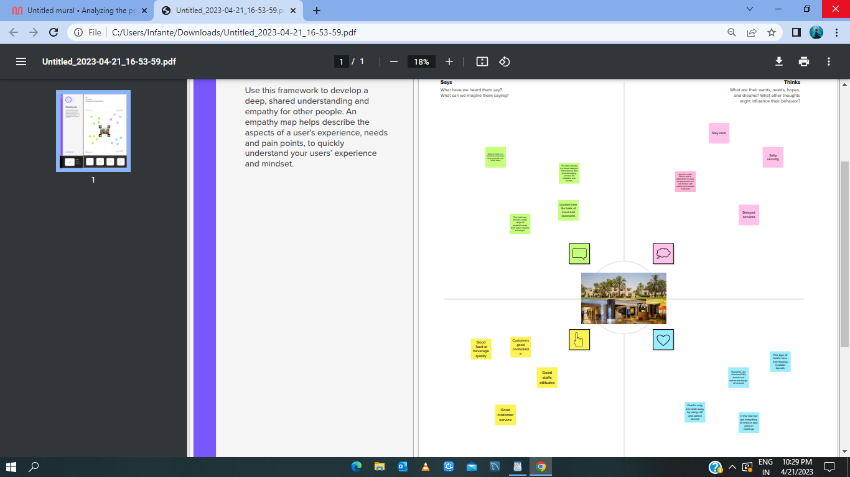

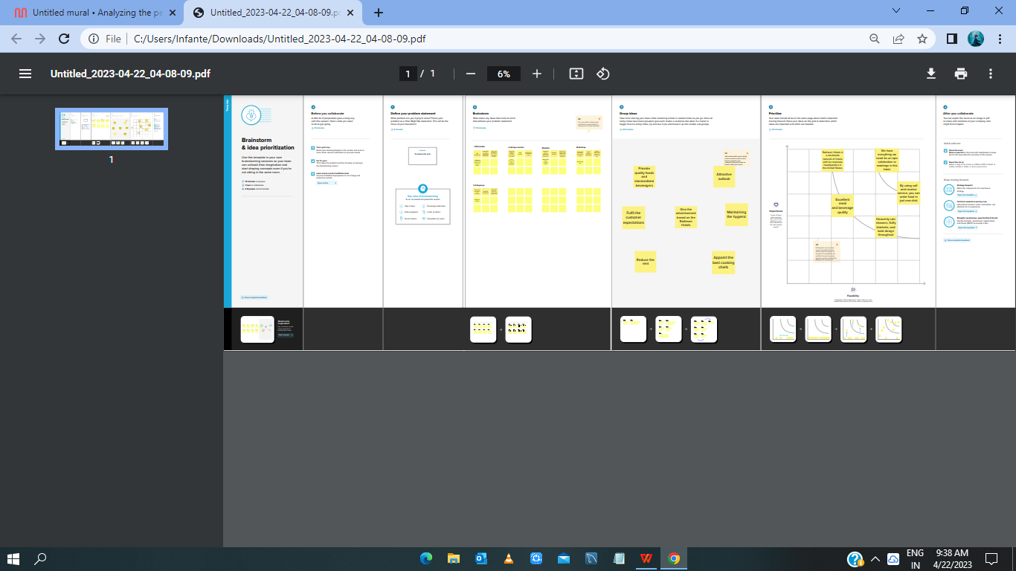

Result

Dashboard:

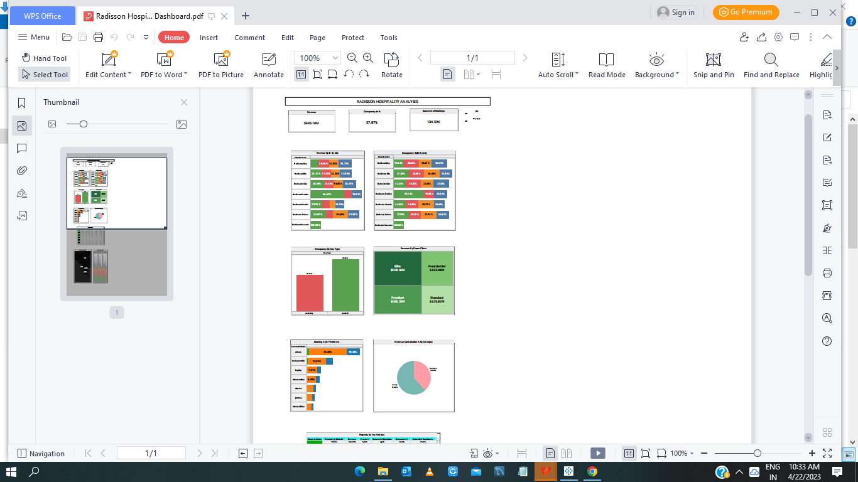

Story:

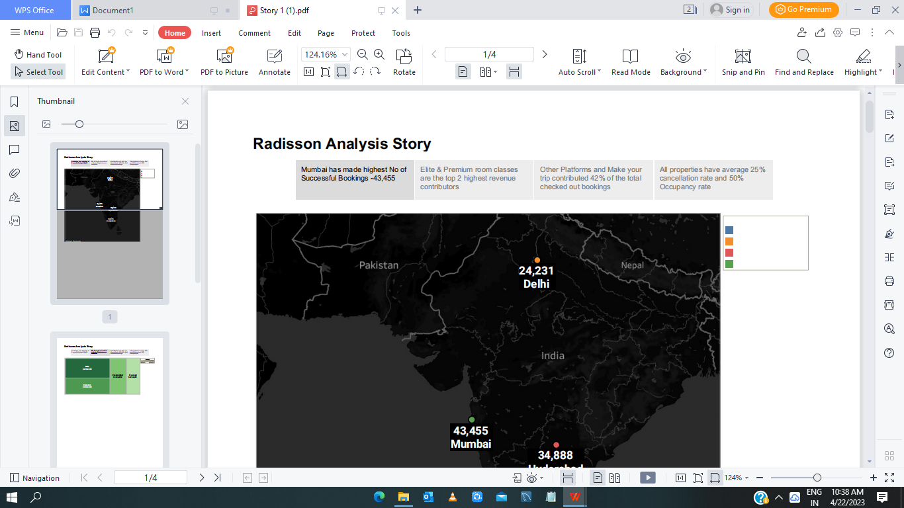

Advantages

* Safty and Security

* Attractive outlook

* Food is only one click

* Wide Network

Disadvantages

* Foods and Rooms are expensive

* Delayed services

Applications

Mumbai has made highest no of Successful Bookings but In

New Delhi has 24,231 . So the Radisson hotels should be in satisfied and good facilities.

Conclusion

By this project,the Revenue is made by city and day type to analysis the customers bookings . Every city has a maximum booking the rooms and average cancelling the bookings.

Future Scope

Location is not that much impressive but the Hotel Rooms are in high facilities.Travel desk is efficient and fast.Radisson hotel to reduce its carbon footprint with a strategy focused on energy efficiency.It can promotes a focus on the balance between work and life.

Appendix